- Click Upload File on the Homepage under Process Payroll.

- Select the site for which you’re submitting contributions, then select the file type. Click Continue.
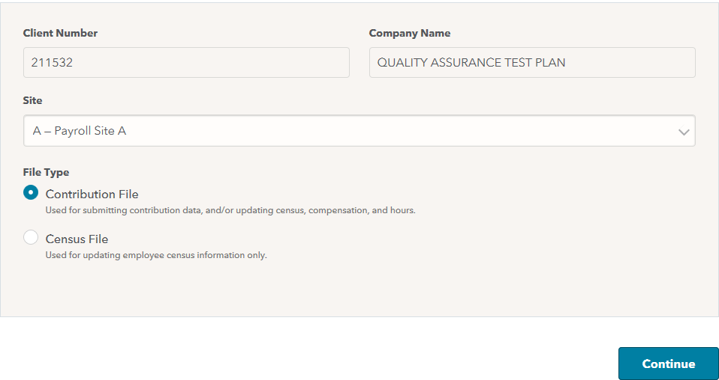

- On the Contribution File Submission page, verify that the contribution date matches the payroll check date.

- Enter the totals for each contribution type being submitted. Include total compensation and total hours based on your plan setup.
- These totals should match your payroll reports.
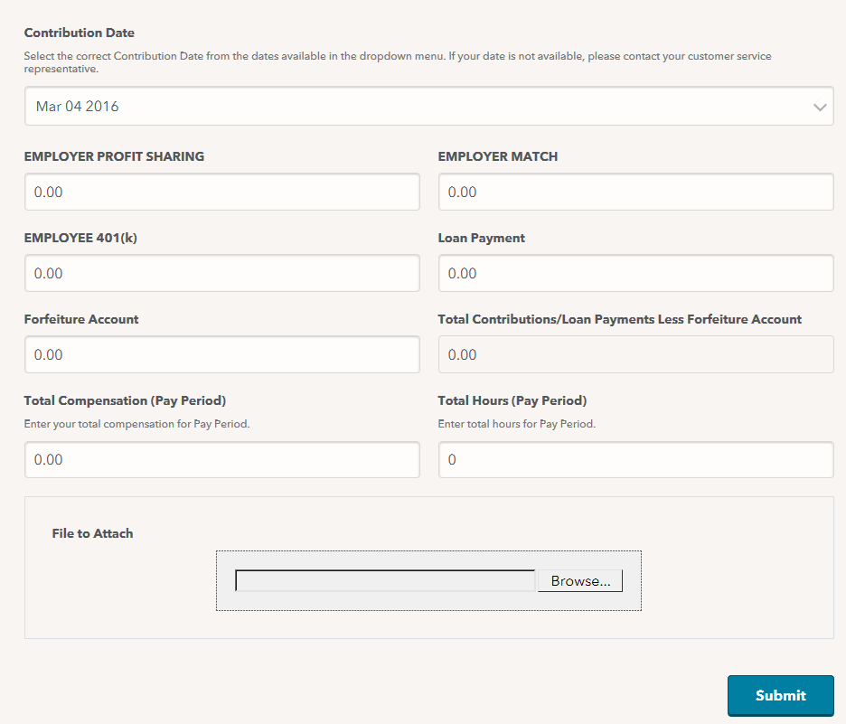

- Click Browse to attach your contribution file.

- Click Submit.

- You’ll receive the following message:
