- From the Homepage, select Employee from the top of the page.
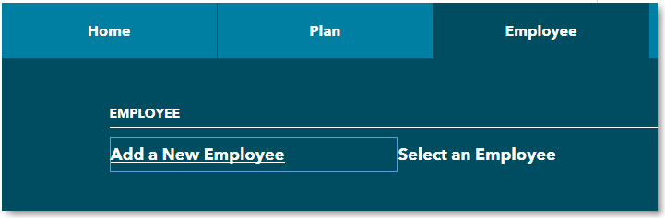

- Click Add a New Employee if you are adding a new hire.
Note: When adding a new employee, all indicative data will need to be entered in order to save.

- Click Select an Employee to update information for a participant already in the system.

- To select the employee you want to edit, either select them from the list on the left or enter the SSN, first name or last name of the person you are needing to update.

- Click Continue.
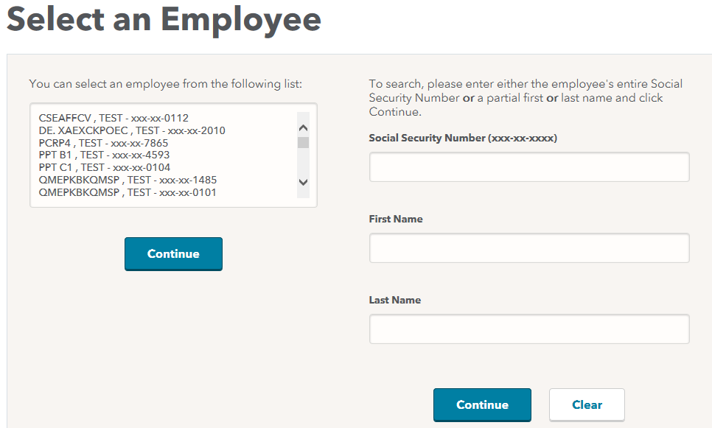

- To edit the information, click the Edit button on the right side of the screen. All fields will become editable except the Social Security Number.
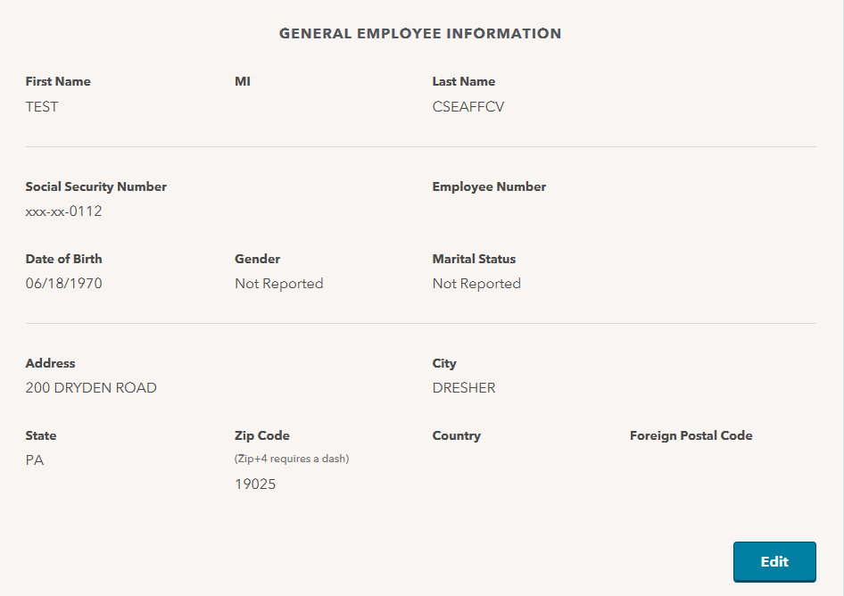

- Once you have entered in all the necessary information, click Save at the bottom of the page.
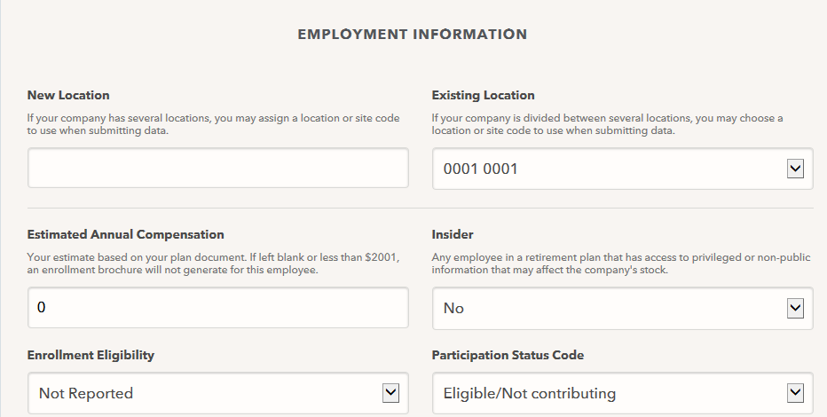

- If you are missing any information, a pop-up window will appear letting you know what data you need to enter before you can move forward.
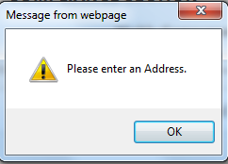

- Enter in the needed data, click Save and a confirmation number will appear.
