1. From the homepage dashboard under Process Payroll, click **Enter Contributions.**

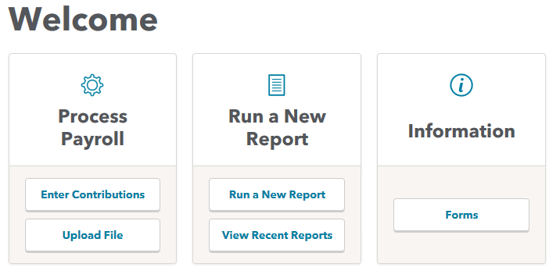

1. Click **Payroll Site** for which you are submitting contributions.

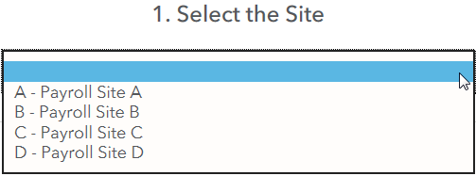

1. Click **Contribution Date** – This must be green.

* If yellow, a contribution has already been started.
  + Click on yellow date
  + Click **Control Totals** and proceed to number 5.
* If red, a contribution has already been processed for that date.

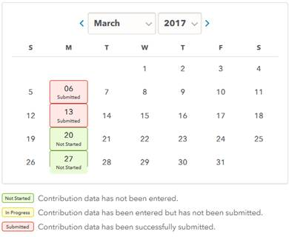

1. For your **first** contribution submission, **only** click **Manually Enter Data.**

Once a contribution file has been funded, you will click **Reload Previous Entry** each time you do the contribution submission. This will bring up the last submission, allowing you to make changes to the dollar amounts listed in order to to match your current payroll report.

1. Enter the control totals from your payroll report into the corresponding field(s) (i.e. Total Hours, Employee 401(k), Total Compensation) and click **Balance Control Totals**.

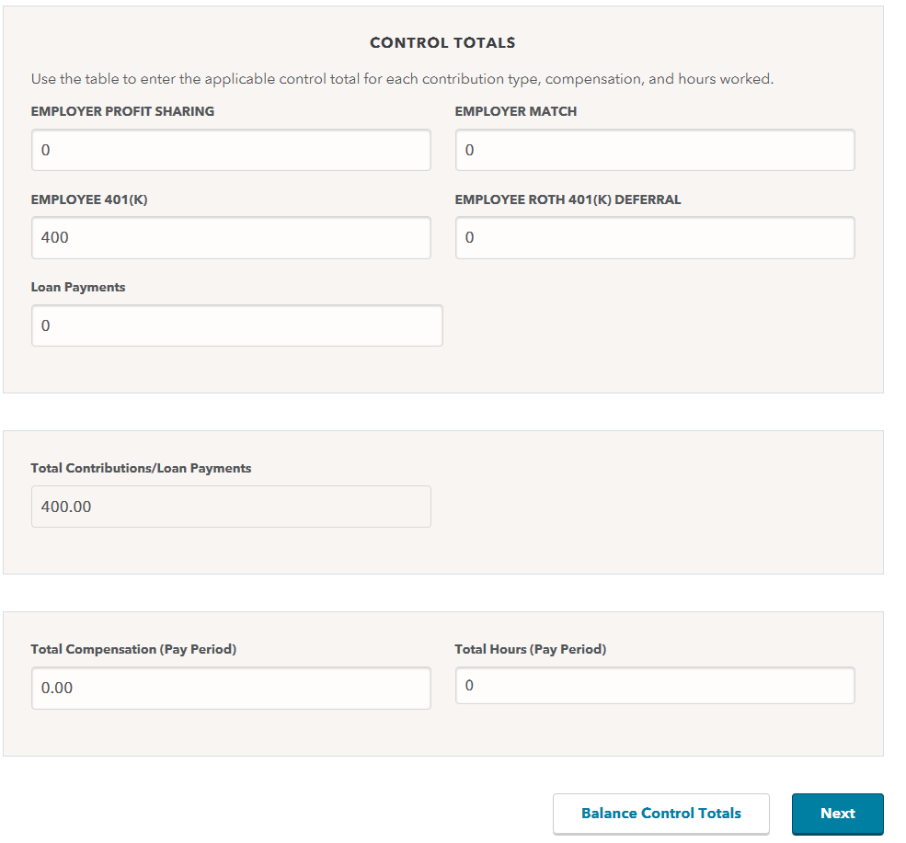

1. Once the screen refreshes, click **Employee Information**.



1. For each employee you want to edit, follow these steps:

* For the first submission you will enter the Social Security Numbers into the **Add An Employee** field and hit the **insert** button. If the Social Security Number you entered matches our system, their first and last name will populate.
* After the first submission, using the Reload feature, you will click the **Edit** button next to the employees Social Security Number to bring up their information to update.

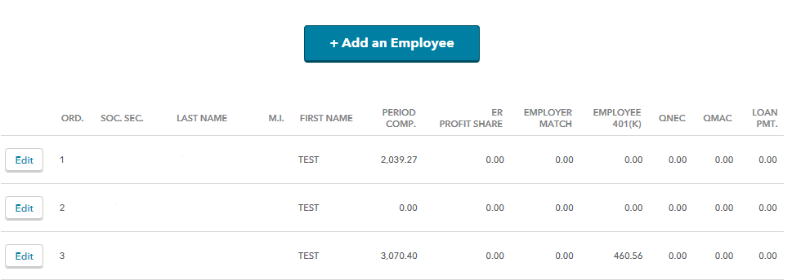

* Click **Update** to change the employee’s information in the center grid.
* To remove an employee’s information, click **Delete** instead of Update.

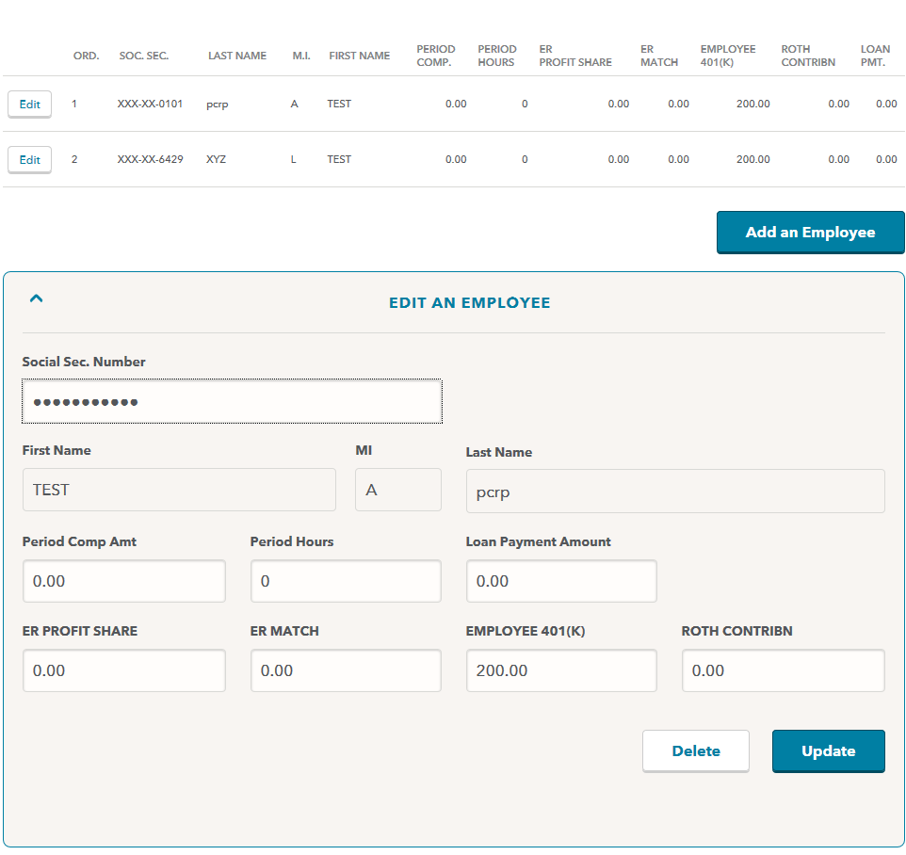

1. When the bottom bar is green, the control totals match the employee totals. Next, click **Submit for Error Checking**.

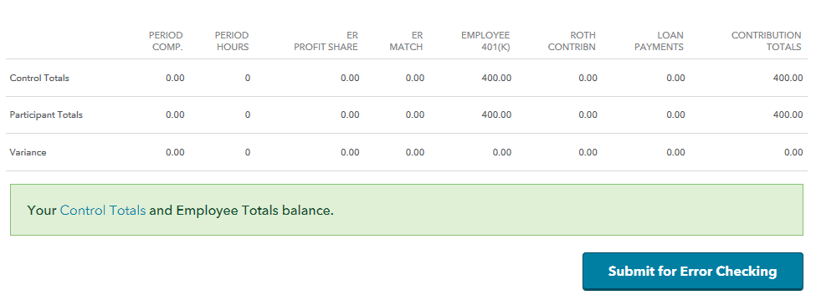

1. Correct any errors if applicable and click **Deposit Verification**.

If you would like a copy of the payroll details for your records, click **Payroll Details Report** and print the report during this step.

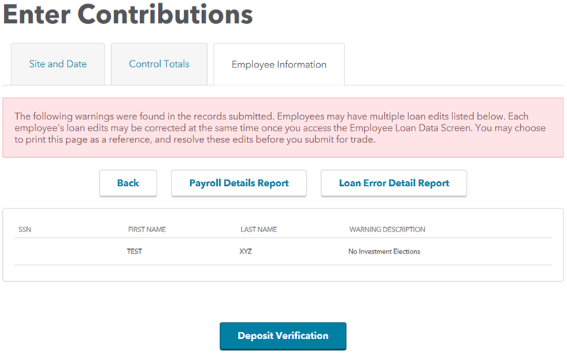

1. Verify the control totals are correct.
2. Select the **Submit For Trade** link at the bottom of the page to submit your contribution for trade.

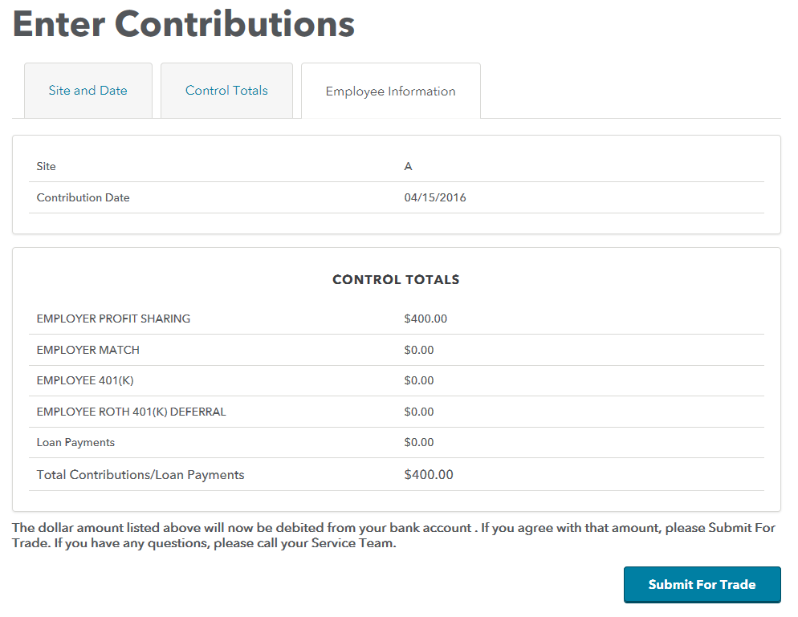

1. You should receive an Automated Funding Request (AFR) confirming the totals on the contribution file and the amount of the check/wire/Automated Clearing House(ACH).

Please Note: If you are set up with ACH you will get the following message **no matching funds at the trust**. This is because the ACH process submits your payroll information and then requests the funds.

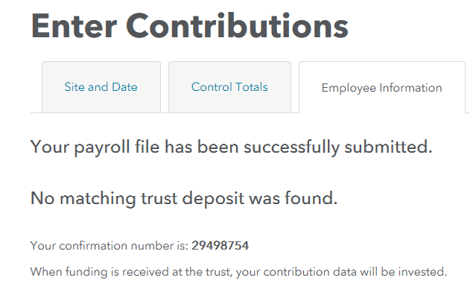

If your assistance is required to complete processing, you will be contacted by a Representative. Please note, your AFR will not be received until the file has been processed.